**Adopting the 4th Industrial Revolution in Today’s Educational System: The Benefits and Ethical Implications**

**ADEBAYO, Enitan Olabisi**

*Department of Computer Science,*

*Federal College of Education (Special),*

*Oyo State, Nigeria*

*adebayoenitan2018@gmail.com*

*&*

**AYORINDE, Ibiyinka Temilola**

*Computer science Department*

*University of Ibadan*

*temiayorinde@yahoo.com*

**Abstract**

*The low outputs in cognitive, affective, and psychomotor domains of learning along with the low 21st-century skills call for a rethink in the educational system. Research revealed that the invention of machines capable of doing hand tools work, steam usage, and advanced other systems of power, and the factory system adoption are the most variations that led to the Industrial Revolution. Research also revealed that the term "Fourth Industrial Revolution" (4IR) was devised in 2016 by Klaus Schwab, the World Economic Forum's Founder and Executive Chairman (WEF). The rapid development and implementation of various technologies have given societies new abilities and capacities to change lives. Presently, society has moved towards the 4IR which is fueled by technology. Adopting the 4IR in the educational system, most especially in developing countries, faces many challenges such as infrastructure, inadequate funding, and skill to make the graduate part in the 4IR. The advanced fusion of the Internet of Things (IoT), quantum computing, gene sequencing, nanotechnology, cloud computing, robotics, genetic engineering, and artificial intelligence (AI) regarded as 4IR keeps changing the way individual works and lives in society. Although the 4IR has its ethical implications such as data sensitivity which led to increased concern about data privacy and management, the benefits of 4IR to all fields of study cannot be overestimated. The educational field is not exempted as it has led to an increase in productivity and efficiency, collaborative teaching and learning, enhancement in decision-making with data-based tools, project-based learning, and specialized learning environment among others. The full adoption of 4IR in all levels of education in developing countries is therefore recommended. Local, state, and federal governments should provide support in terms of infrastructure, funding, and skilled personnel for all tertiary institutions within their jurisdiction towards the implementation of 4IR.*

**Keywords:** Fourth Industrial Revolution (4IR), Educational System, Ethical Implications.

**Introduction**

The low outputs in cognitive, affective, and psychomotor domains of learning along with the low 21st-century skills call for a rethink in the educational system. Research revealed that the invention of machines capable of doing hand tools work, steam usage, and advanced other systems of power, and the factory system adoption are the most variations that led to the Industrial Revolution. The term "Fourth Industrial Revolution" (4IR) was coined in 2016 by Klaus Schwab, the World Economic Forum's Founder and Executive Chairman (WEF). The 4IR is a convergence of advancements in the Internet of Things (IoT), quantum computing, gene sequencing, nanotechnology, cloud computing, robotics, genetic engineering, artificial intelligence (AI), and other fields. Yusuf et al. (2020) opine that the 4IR advocates for the transfer of information from digital fields to offline reality through connected systems to upturn people's lives and the 4IR technologies have entered into unpredictable areas, that include but are not limited to medicine, education, economy. Similarly, Ally and Wark (2020) opined that the digital revolution is driving the 4IR, which combines the physical, digital, and biological domains to develop systems that serve humans and protect the environment.

All 4IR educational institutions need to prepare their graduating students with the abilities and skills to generate a culture that mends the sustainability of advanced technology in a thoughtful and responsible manner. However, adopting the 4IR in the educational system, most especially in developing countries, faces many challenges such as infrastructure, insufficient funding, and skilled personnel to prepare the graduate to participate in the 4IR.

The 4IR has now become a buzzword, but despite this, most people are yet to be aware of how this new digital landscape will have a significant impact on their daily lives (Rumi et al., 2020). The 4IR necessitates that the educational domain synchronizes the process of education so as to enable the interaction between the graduates and or the students with the modernized changes (Azhari et al., 2020). There are lots of benefits that the 4IR can bring to the educational system if adopted to its fullest such as increased job opportunities, inspired innovation, increased productivity and efficiency, creation of competition, collaborative teaching, and learning, reduced influences of borders, enhancement in decision making with data-based tools, the transformation of the world from a rural to urban culture, project-based learning, and a specialized learning environment among others.

However, the 4IR adoption by developing countries may not yield the expected results if the developing country cannot afford the resources required for the success of 4IR (Olaitan, et al., 2021). The successful implementation of the 4IR in a specific country rests on the value systems, cultures, norms, politics, and the country’s economic capacity (Rumi et al., 2020). Developing countries can skip development stages and bring into line with developed markets by accepting emerging technologies like big data analytics, artificial intelligence (AI), and blockchain (Manda & Ben, 2019).

**Historical Development of the 4th Industrial Revolution**

The term Industrial Revolution (IR)' generally denotes a period in which technological transformations lead to dramatic and vast changes in individuals' and countries' socioeconomic conditions (Olaitan, et al., 2021). The Industrial Revolution was an era in which technological inventions adjusted the operation of the industry, transforming production and consumption and having an impact on labor and society as a whole (Maisiri, 2020). The Industrial Revolution (IR) witnessed several steps that allowed the transition from a farming and feudal society to an industrial and capitalist society and then to a post-industrial or services society, with the gradual release of the labour force from physical activity and mental efforts afterward in favor of more striking creativity (Prisecaru, 2016).

The introduction of water and steam power, and mechanization increased led to the first Industrial Revolution (1IR) (Merisi & Pillay, 2020). Maisiri (2020) reported that the 1IR (1st Industrial Revolution) occurred between 1750 and 1850 in Great Britain and caused a key shift in the industry’s ways of operation. Contrarily, Olaitan, et al., (2021) reported that the 1IR occurred between 1760 and 1840 which was the period of steam locomotive power invention that revolutionized textile industries in other developed countries such as England. However, 1IR's analytic lens then delivered the conceptual framework for determining the Industrial Revolution's nature (Maisiri, 2020). One of the modern public education systems established in the eighteenth century is the university which is the reply to the social and economic dynamics that yielded to the Industrial Revolution 1.0 also known as the "Educational Revolution" (Yülek, 2022). The university is therefore projected to be involved in theoretically spurring technological advancement, scientific research, and innovation (Yülek, 2022).

The 2IR (second Industrial Revolution) was defined by advances in chemical engineering, electrification, and the production of mass assembly lines (Merisi & Pillay, 2020). The 2IR occurred towards the end of the 19th century to the beginning of the 20th century with the advancement in mass production, electricity, and division of labour. The 3IR (Third Industrial Revolution) acknowledges the impact of automation, web-based connectivity, digitization, and electronics in the home and work lives (Merisi & Pillay, 2020). The 3IR (Third Industrial Revolution) started in the early 1950s with the advancement in electronics, automated production, and information technology (IT). In this era, higher education is becoming more accessible, online learning platforms shape the way students learn, and internet access is becoming the standard (Penprase, 2018).

The rapid acceptance of novel and emerging technologies such as IoT (Internet of Things) and the IOS (Internet of Services) ushered in the 4IR which has demanded a new breed of worker (Manda & Ben, 2019). The 4IR is embedded in the integration of networked technologies to enable automation, with the introduction of the IoT and AI into our daily lives (Ally & Wark, 2020). Automation of this type is also used in the education sector (Ally & Wark, 2020). The world economy is currently in its Fourth Industrial Revolution (4IR), which was first mentioned in the 1940s. Some examples of 4IR in education include widespread customization of learning, digitization, automated assessment, as well as the portability of student records (Ally & Wark, 2020). The 4IR emphasizes digital technologies, AI, neuroscientific advances, genetic design, big data analytics (Merisi & Pillay, 2020; Maisiri, 2020) 3-D simulation, virtual and augmented reality, and machine learning among other things (Merisi & Pillay, 2020). This revolution is predicated on increased connectivity, as well as the cyber-security threats increased possibility (Merisi & Pillay, 2020). However, the 4IR emphasizes, among other things, critical thinking, creativity, emotional intelligence, communication skills, and problem-solving (Penprase 2018) which help in the achievement of independent and personalized Learning.

In a nutshell, Yusuf et al. (2020) reported that the steam engine invention in 1790 launched the first Industrial Revolution that was used by farmers for agriculture and feudal society for manufacturing while the invention of the internal combustion engine in 1900, began the Second The Industrial Revolution ushered in an era of electric power and oil-fueled machines. The Third Industrial Revolution started in 1960, with the invention of electronics and information technology to automate manufacturing in the early 2000s. The fourth generation (4IR) began which involved computer-generated products, such as intelligent agents, nanomaterials, 3D printing technology, and biotechnologies.

The Third Industrial Revolution began in 1960, with the invention of electronics and information technology to automate manufacturing and in the early 2000s, the fourth generation (4IR) began which involved computer-generated products, such as intelligent agents, and nanomaterials, 3D printing technology, and biotechnologies.

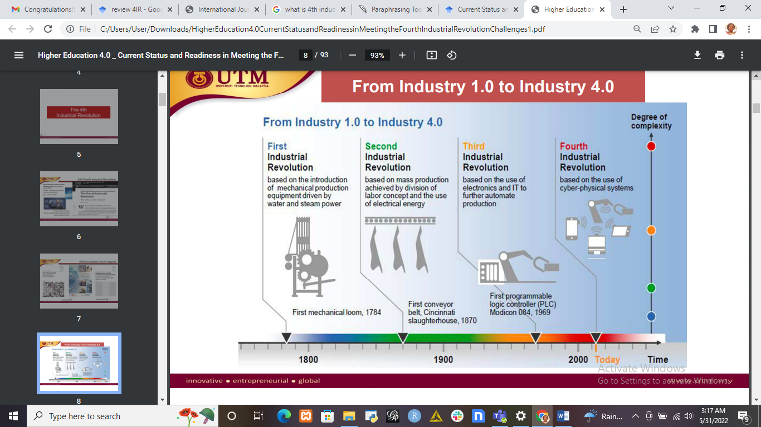

**Figure 1: Industry 1.0 to Industry 4.0 (source: Selamat et al., 2017)**

**Benefits of 4th Industrial Revolution**

One of the key effects of the Fourth Industrial Revolution was an increase in human productivity. Smart choices become available with the use of technologies such as AI and automation augmenting individuals’ professional lives. The benefits of the Fourth Industrial Revolution include but are not limited to productivity increment, efficiency, increase in process quality, and employees’ greater safety by minimizing jobs in hazardous environments, improved decision-making with data-based tools, and improved competitiveness through customized product development. Higher education is greatly impacted by the 4IR since it creates system improvements by removing all barriers to innovation.

The critical enabler behind the transformation of the majority of factory activities via a set of built-in features into a smart manufacturing framework is the 4IR (Fanoro et al., 2021). The various roles of AI have attracted public attention starting with Google's Alphago which has made AI not only an imagined technology but a real technology that is capable of bringing a ripple effect in the entire humanity (Seo, 2019).

**Ethical Implication of 4th Industrial Revolution**

Research revealed that the ethical implications of the 4IR include the following:

1. **Potential job losses:** This is one of the 4IR ethical issues. Many companies and industries have reduced the number of their employees due to the various advantages of the 4IR such as automation. Although, automation has enabled industries and establishments to reduce their expenditure and increase their profitability and productivity but has also created a threat to employability chances at the same time. This threat to employment is not limited to industries but has extended to the educational field. Many institutions have outsourced their educational tutor from outside their countries since the tutor can deliver lectures remotely and supervise any assigned supervisee remotely. Rumi et al. (2020) reported that a recent study report shows that 60% of low-education, 48% of medium, and 19% of higher-education jobs will be displaced by automation.
2. **Skills challenges:** Skill challenges are struggles that are far away from contests or discussions. They demand a high sense of creativity, resourcefulness, and teamwork. The 4IR presents a number of implications for skills development and education. Some of these implications include reinventing education systems and strategic approaches to increase creativity and innovation.
3. **Infrastructure challenges:** Fourth industrial revolution infrastructural challenges include service level agreements and what to do internally, making IT objectives business priorities, increase in cyberattacks and security breaches, lack of powerful computing platforms, as well as managing vast amounts of data.
4. **Security and privacy:** Security defends integrity, information availability, and confidentiality, meanwhile privacy has to do with privacy human rights with admiration to individual data. Privacy triumphs when dealing with individual data processing, meanwhile security has to do with protecting information assets from unauthorized access.
5. **Data Sensitivity:** The rise in technology has also led to increasing concerns over data and internet protocol (IP) privacy, ownership, and management. Other ethical issues in the 4IR include misuse of personal information, misinformation and deep fakes, lack of oversight and acceptance of responsibility, use of AI, as well as autonomous technology.

**Conclusion**

In a nutshell, the main advantages of the 4IR include increased knowledge leads to increased efficiency, which saves time and money, resolving workforce issues, leveraging existing data and ample additional data sources, existing manufacturing processes transformation, and end-to-end information stream creation across the value chain. The 4IR has shown significant dimensions in all aspects of the world and its adoption has shown significant complexity throughout the developed countries. The stream of the 4IR has taken the top place throughout the world and its flow has led to a significant impact on national politics and economics. The benefit of 4IR in the educational system includes but are not limited to a high increase in productivity and sustainable ICT development, a high increase in efficiency, collaborative teaching and learning, enhancement in decision-making with data-based tools, project-based learning, implementation of flipped classroom teaching and specialized learning environment among others.

**Recommendations**

The following are suggested for adopting the 4th industrial revolution in today’s educational system:

1. All stakeholders in all levels of education in developing countries must adopt the full implementation of 4IR into their educational system in order to increase their productivity, efficiency, and quality in processes, and greater safety for workers by reducing jobs in dangerous environments.
2. Both lecturers and students at tertiary institutions in developing countries should endeavor to embrace technology to its fullest and continue to develop their skills technologically in order to be able to shift to the new paradigm of 4IR.
3. Every lecturer and student in tertiary institutions in developing countries must have a module page where they will be uploading their module resources for teaching and learning sake in order to equip their graduates with needed skills that will enable them to compete with their international colleagues.
4. All tertiary institution students need to have a learning management system (LMS) dashboard where they will be uploading their assessment work and accessing their learning materials arranged section by section with respect to curriculum and minimum standard.
5. Periodical training programme for all the educational stakeholders in developing countries on the use and implementation of 4IR in the educational system must be sponsored by the federal government of that country in order to motivate the educational stakeholders to embrace the implementation of the 4IR to its fullest.
6. Local, state, and federal governments should provide support in terms of infrastructure, equipment, funding, and skilled personnel for all tertiary institutions within their jurisdiction towards the implementation of 4IR.

**References**

Ally, M., & Wark, N. (2020). Sustainable development and education in the fourth industrial revolution (4IR).

Azhari, B., Ma’awiyah, A., Hamid, M., Ridhwan, M., & Bahri, S. (2020, February). E-Learning as a connector among education institutions in the 4th industrial revolution. In *Journal of Physics 1471(1)* 012024. IOP Publishing.

Fanoro, M., Božanić, M., & Sinha, S. (2021). A review of 4ir/5ir enabling technologies and their linkage to the manufacturing supply chain. *Technologies*, *9*(4), 77.

Maisiri, B. G. (2020). The idea of the 4th industrial revolution: Attitudes of academic leaders at an urban South African University and its implications for university practice. *Faculty of Humanities, School of Education*.

Manda, M. I., & Ben Dhaou, S. (2019). Responding to the challenges and opportunities in the 4th Industrial Revolution in developing countries. In *Proceedings of the 12th International Conference on Theory and Practice of Electronic Governance* (pp. 244-253).

Merisi, P., & Pillay, A. (2020). Emergency remote teaching in higher education: How academics identify the educational possibilities. *Alternation African Scholarship Book Series*, *2*, 74-91.

Olaitan, O. O., Issah, M., & Wayi, N. (2021). A framework to test South Africa's readiness for the fourth industrial revolution. *South African Journal of Information Management*, *23*(1), 1-10.

Penprase, B. E. (2018). The fourth industrial revolution and higher education. *Higher education in the era of the fourth industrial revolution*, *10*(1), 978-981.

Prisecaru, P. (2016). Challenges of the Fourth Industrial Revolution. *Knowledge Horizons. Economics*, *8*(1), 57.

Rumi, M. H., Rashid, M. H., Makhdum, N., & Nahid, N. U. (2020). Fourth industrial revolution in Bangladesh: prospects and challenges. *Asian Journal of Social Sciences and Legal Studies*, *2*(5), 104-114.

Selamat, A., Alias, R. A., Hikmi, S. N., Puteh, M., &Tapsi, S. M. (2017). Higher education 4.0: Current status and readiness in meeting the fourth industrial revolution challenges. *Redesigning higher education towards industry*, *4*, 23-24.

Seo, H. J. (2019). A preliminary discussion on policy decision-making of AI in the fourth industrial revolution. *Informatization Policy*, *26*(3), 3-35.

Yülek, M. A. (2022). Public Education and the University. *Towards Third Generation Learning and Teaching: The Contours of New Learning*.

Yusuf, B., Walters, L. M., & Sailin, S. N. (2020). Restructuring Educational Institutions for Growth in the Fourth Industrial Revolution (4IR): A Systematic Review. *Int. J. Emerg. Technol. Learn.*, *15*(3), 93-109.